# Flow Board

## Introduction:

The Flow Board module of the LibreHealth EHR system is an organized way to keep track of patients’ status and progress through their appointments. It synchronizes with other modules of the EHR system, particularly with the Calendar and the Patient/Clinic modules. Any updates made to these other modules -- for instance changing the appointment date for a patient’s visit -- are reflected in the Flow Board. This way the real time display of a patient’s progress through an appointment is a primary function of the Flow Board.

This document details the workflows that are part of the flow board and Global Settings modules and provides a guide for new users to navigate the system. If you are starting with a fresh installation of the system, note that the guides presented in this document are based on populated patient data. This may not match what you see. However, the instructions and procedures described below should all be available to you.

The document is organized as follows: the procedure section outlines the steps for accessing and using Flow Board. The section begins with details on accessing the Flow Board and setting layout preferences. The following two sections describe key features of the flow board, specifically, how to use the selection and filtering tools on appointments and how to access the patient flow board report. Finally, a guide to customizing global settings for the EHR system is presented.

I created this documentation as a starter task for the Outreachy 2020 internship application and I’m looking forward to continuing contributing to LibreHealth EHR.

Pranathi Ernala, 5 April 2020.

## Procedure:

### **Accessing Flow Board on LibreHealth EHR**

### 

### To access the flow board,

1. First login to the EHR system that lands on the home page.

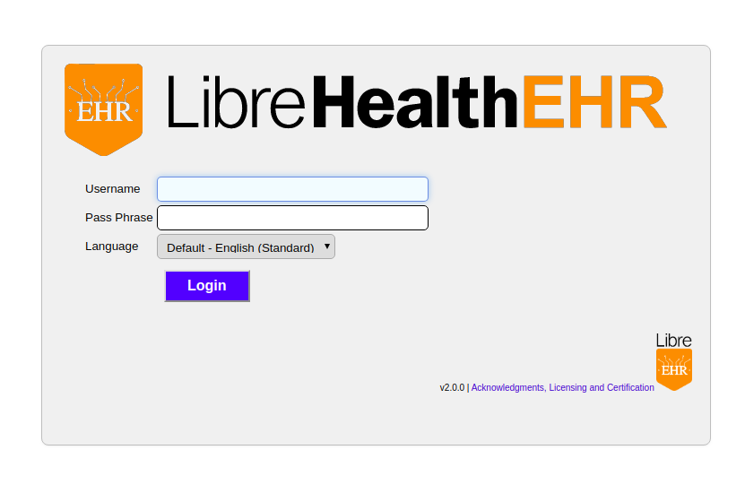

Upon login, the home screen displays two panels, calendar and patient finder.

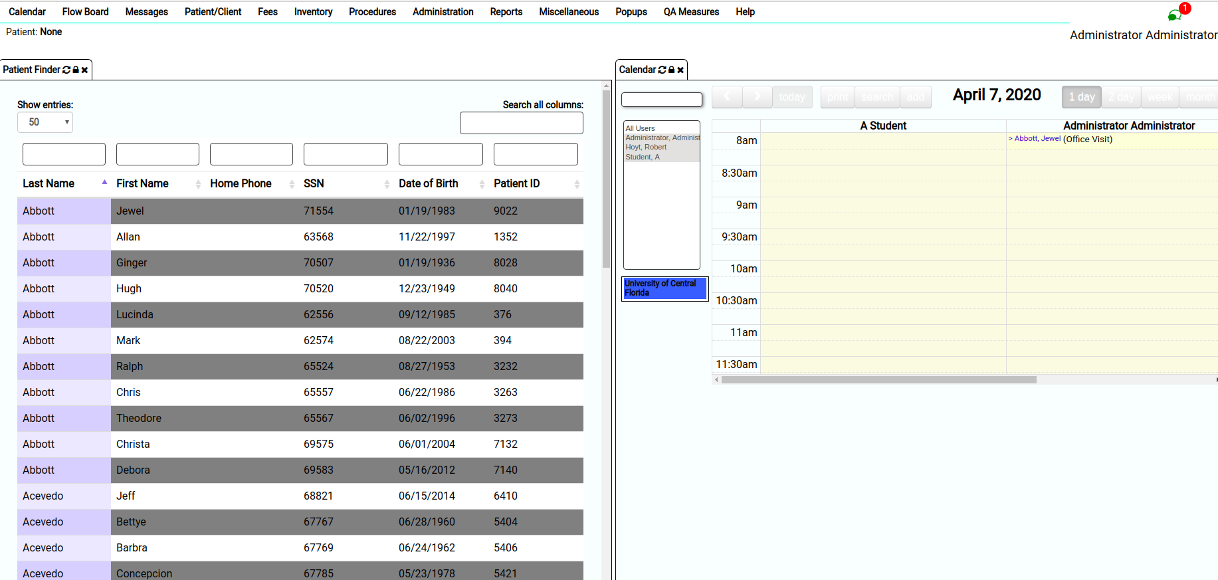

1. Find the flow board tab on the navigation bar on the top left. Click on “Flow Board”

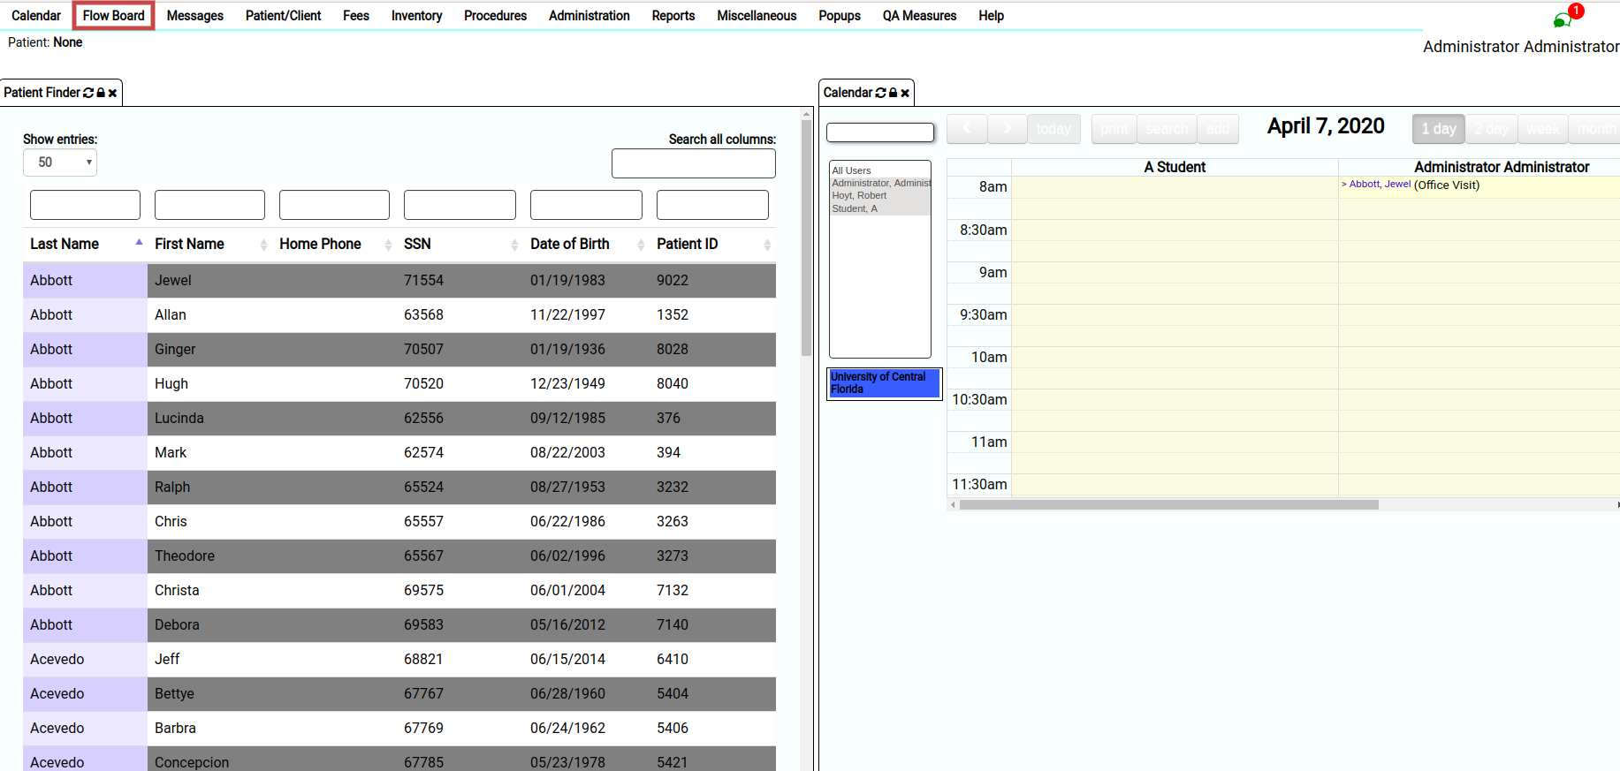

1. The Flow Board panel should now appear on the screen. It appears as shown in the figure below.

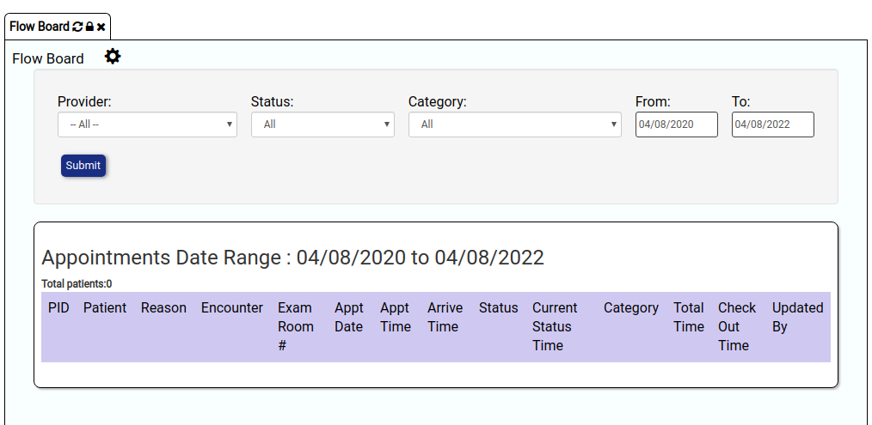

### 

### **Patient Flow Board Operation**

Flow Board is closely synchronized with Calendar and changes made to one are reflected in another. Calendar serves the purpose of scheduling patients and adding new information about appointments. Flow Board, on the other hand, serves as an information visualization panel to see information about patients and appointments at different granularities. In this document, the focus is on features of the Flow Board but it is important to note that data is entered through the Calendar.

### **Setting flow board preferences**

Flow Board provides options to customize the layout and select patient information that one wants to see on the Flow Board panel. You can change the default settings by clicking on the gear icon next to the “Flow Board” title as highlighted using a red circle below.

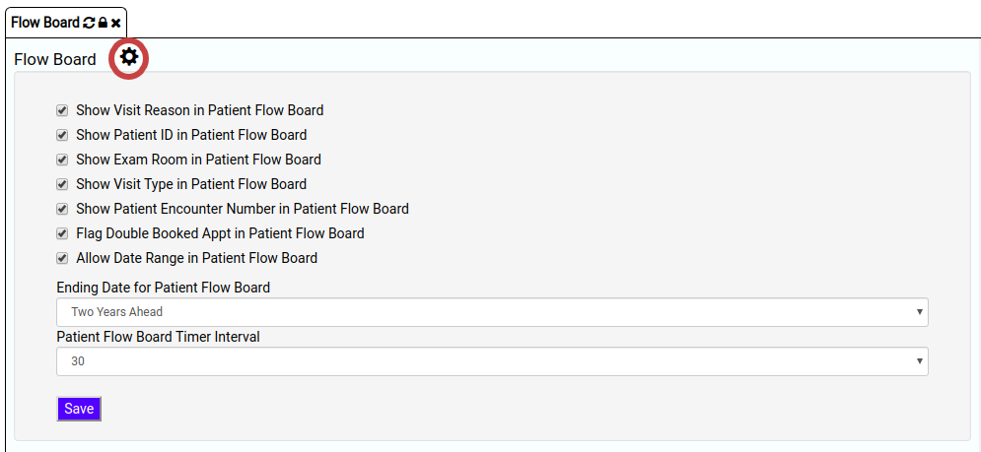

The following options are provided to customize the view of the Patient Flow Board:

* **Show Visit Reason in Patient Flow Board:** By selecting the checkbox, this displays the visit reason for every patient appointment recorded in the system. You can disable this feature by deselecting the checkbox.
* **Show Patient ID in Patient Flow Board:** By selecting the checkbox, this displays the unique ID that is assigned to every patient. You can disable this feature by deselecting the checkbox.
* **Show Exam Room in Patient Flow Board:** By selecting the checkbox, this displays the room information for every scheduled patient appointment recorded in the system. You can disable this feature by deselecting the checkbox.
* **Show Visit Type in Patient Flow Board:** By selecting the checkbox, this makes visible the information about the type of visit for every patient appointment recorded in the system. You can disable this feature by deselecting the checkbox.
* **Show Patient Encounter Number in Patient Flow Board:** By selecting the checkbox, this displays the Encounter Number for every patient appointment recorded in the system. You can disable this feature by deselecting the checkbox.
* **Flag Double Booked Appt in Patient Flow Board:** By selecting the checkbox, appointments that have been double-booked are flagged and highlighted in orange. You can disable this feature by deselecting the checkbox.
* **Allow Date Range for Patient Flow Board:** By selecting the checkbox, this option enables searching for appointments in the Appointment Table for a range of dates. You can disable this feature by deselecting the checkbox.
* **Ending Date for Patient Flow Board:** This option lets you choose an end date for the Flow Board’s time range display. By clicking on the downward arrow and selecting a time frame from the dropdown, you can limit how much information about patient appointments is visible in the Flow Board. Note that this option is applicable only when the “Allow Date Range for Patient Flow Board” is selected.

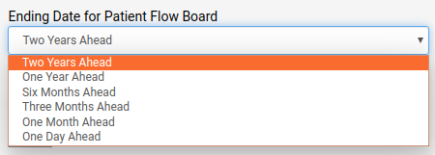

* **Patient Flow Board Timer Interval**: This option allows you to choose the time (in seconds) after which the Flow Board will be automatically refreshed to display the latest information. The default time interval is 30 seconds i.e. the latest information is refreshed every 30 seconds. This feature can be disabled by selecting “No automatic refresh”.

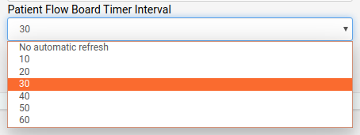

You can also manually refresh the Flow Board panel by clicking on the arrow button on the flow board tab.

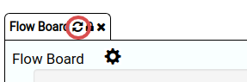

### **Features of the Flow board: Selection and Filtering from Appointments**

Flow board provides an option to filter information across all patients by the provider, status, category and date selections. Once the selections are submitted, the filtered information is presented in the Appointments table below.

* **Provider**: This refers to the health care provider associated with an appointment. The default setting for this option displays information associated with all providers in the system. To see information associated with a specific provider, click on the downward arrow under “Provider” that opens the drop down list and select the provider of your choice.

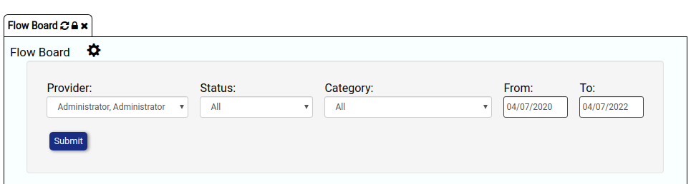

* **Status**: This refers to the various stages of patients’ flow in the healthcare system. By default, information related to all statuses is displayed. To see information belonging to a specific status, for example cancelled appointments, click on the downward arrow below “Status” that opens the drop down list to choose from various statuses.

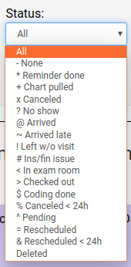

* **Category**: This refers to the type of visit associated with an appointment. For example, whether it is a new patient, established patient or a no show appointment. By default, information related to all categories of visit is displayed. To see information specific to a category of visit, click on the downward arrow below “Category” that opens the drop down list to choose from various categories.

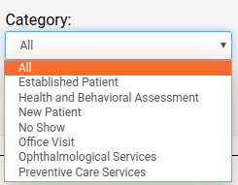

* **Date**: This refers to the date range to display information from the appointments table. By default both the “From” and “To” fields are set to the current date. To change the date range, click on the date field under “From” and choose the desired start date. Similarly, click on the date field under “To” and choose the desired end date. To move to the desired Month, use the left and right arrows to move backwards and forwards respectively. Once you see the calendar for your desired month, click on the date of choice. Note that the chosen end date i.e. “To” date must be after the start date i.e. “From”. Otherwise, the system throws an error in displaying appointments.

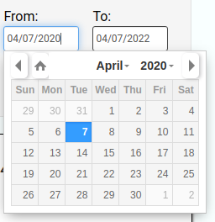

To filter appointments information across all patients,

1. Choose the desired values for provider, status, category and date.



1. Click on the submit button.

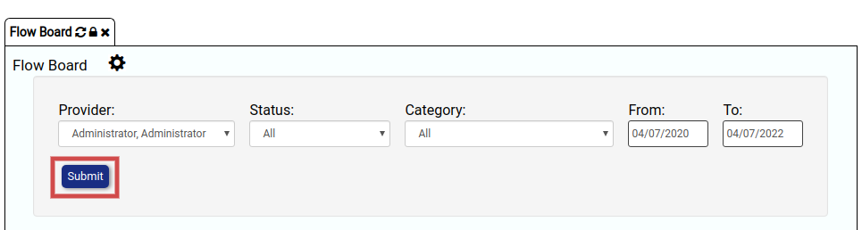

1. Once you click the submit button, the filtered patient information is displayed in the appointments table below.

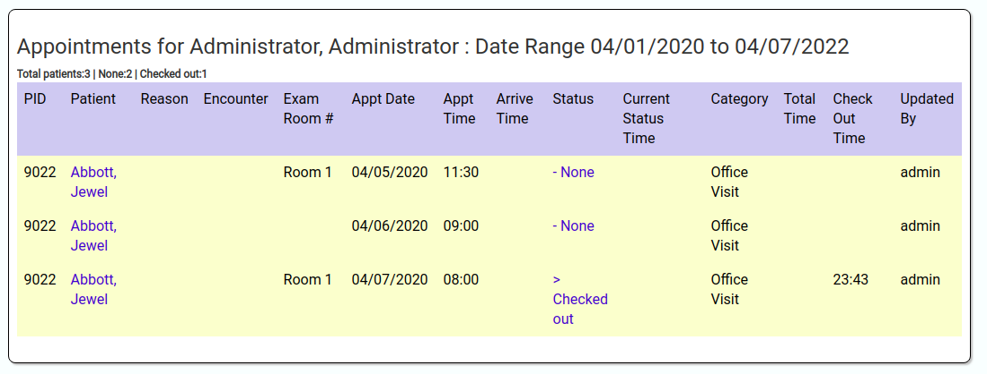

The appointments table displays the following information. Some of this information can also be updated on the Flow Board.

* **PID**: This column displays the unique Patient ID for each patient.
* **Patient**: This column displays the name of the Patient. To view additional information about a specific patient’s appointment, you can click on the patient’s name. This opens up a new panel with the information specific to that patient.

1. To view additional information, click on Patient’s name (highlighted in Red below)

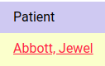

1. This opens a new panel with detailed information about the patient’s status and appointment including demographics, patient reminders, notes, disclosures, labs, vitals, allergies, past and future appointments, medication, prescriptions etc.

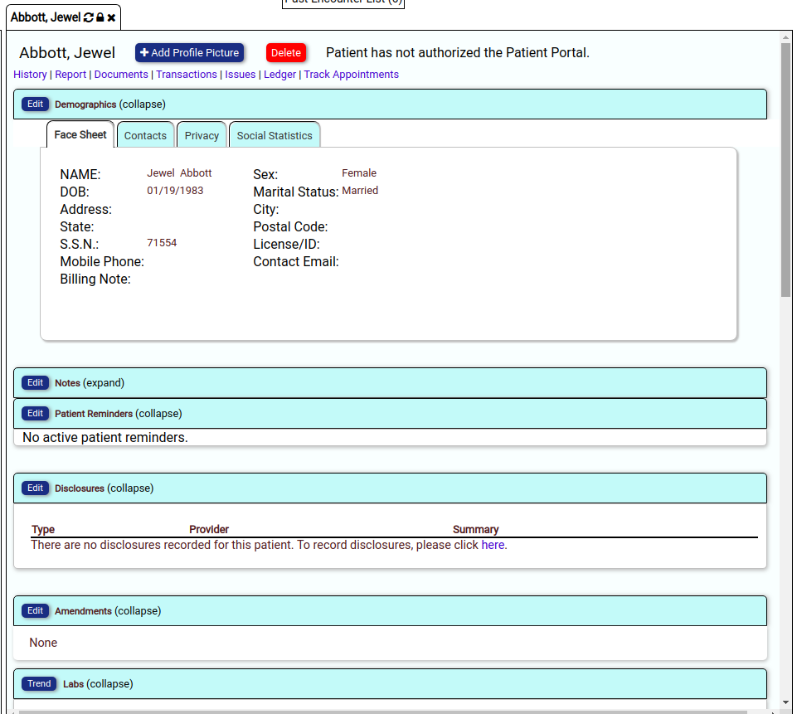

* **Reason**: In the appointments table, this column shows the reason for the patient's appointment.
* **Encounter:** This column displays the Encounter number associated with each patient appointment.
* **Exam Room**: This column displays the information of the room in which the patient has checked into.
* **Appt Date**: This column contains the appointment date.
* **Appt Time:** This column contains the appointment time.
* **Arrive Time:** This column contains the time at which the patient arrived for an appointment.
* **Status**: This column contains the current status of the patient appointment. Flow Board provides an option to change the appointment status.

To change the appointment status,

1. Click on the given status of the patient (highlighted in red below)

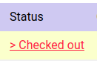

1. This opens a new pop-up window. Change the status type in the pop-up window along with the exam room number.
2. Click on save to update the status information.

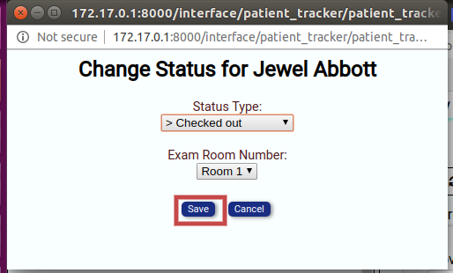

* **Current Status Time:** In the Appointments table, this column displays the duration the patient spent in their current appointment status.
* **Category:** This column displays information about the category of patient appointments.
* **Provider:** This column displays the name of the provider associated with the patient appointment.
* **Total Time:** This column displays the total time the patient spent within the appointment since arrival to check out.
* **Updated By:** This column shows the LibreHealth EHR system user who most recently updated information about the appointment.

### **Patient Flow Board Report**

The appointments table displayed on the Flow Board above shows information across all patients. However, the LibreHealth EHR system also provides a way to check where a given patient is within the appointment through the Patient Flow Board Report.

To access Patient Flow Board Report,

1. Click on Reports on the navigation bar (highlighted using the red rectangle below).

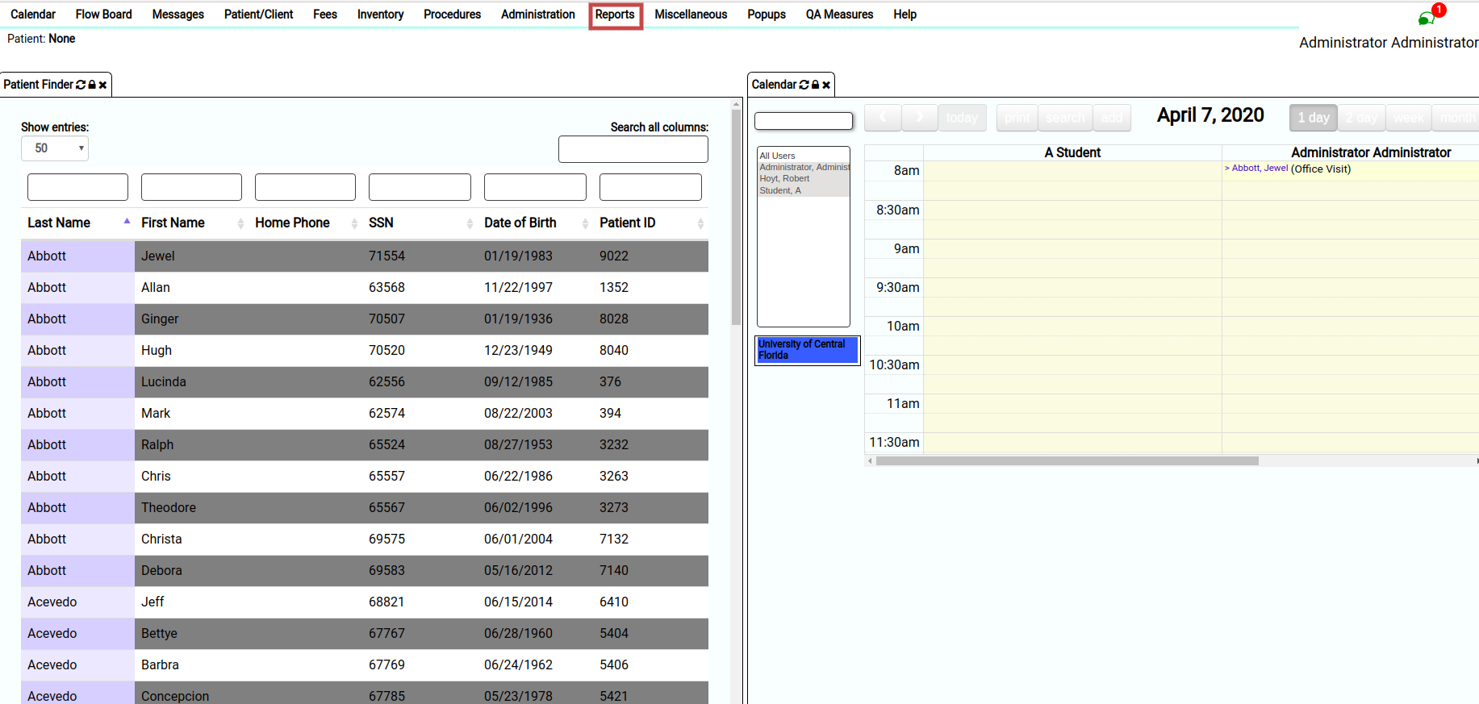

2. Click on Visits.

3. Click “Patient Flow Board” within Visits.

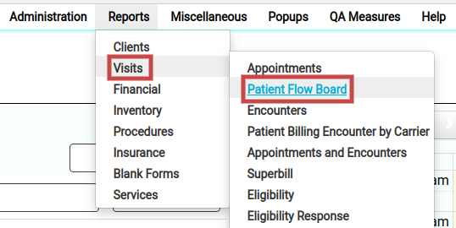

This opens a new panel for Patient Flow Board Report through which you can set filters to obtain the specific report for a patient.

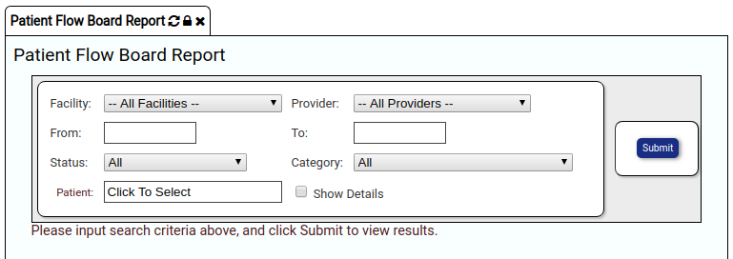

The Patient Flow Board Report allows filtering based on the following search criteria:

* Facility: To generate Patient Flow Board Report for a specific facility.
* Provider: To generate Patient Flow Board Report for a specific provider.
* From/To: The start and end dates for which the report is to be generated.
* Status: The status of the appointments for which the report is to be generated.
* Category: The category of the appointment for which the report is to be generated.
* Patient: The patient name for whom the report is to be generated.

To see where a patient is within an appointment,

1. Enter the search criteria for facility, provider, from and to dates, status, category and patient name. For example, let’s look for a patient named “Jewel Abbott” and their information between April 4-7, 2020.
2. Click on submit once you have chosen the search criteria (highlighted in red).
3. Additionally, to print the report click on print (highlighted in green).

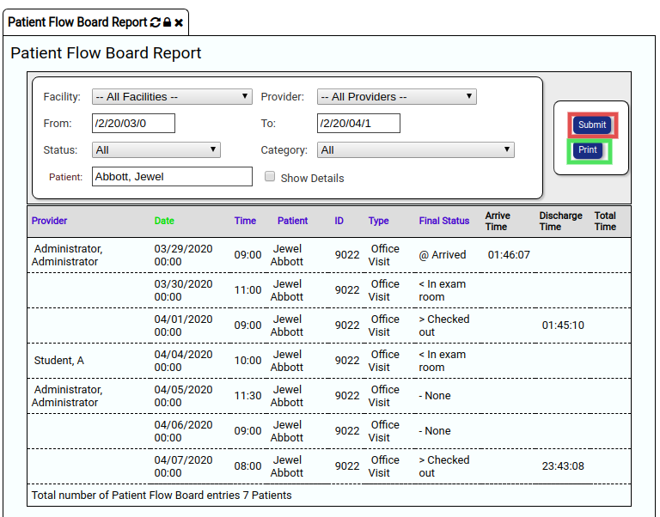

As seen in the figure above, the Patient Flow Board Report shows the time a patient spent in each status (from arrival to check out) per appointment recorded in the system.

### **Global Settings**

The Global Settings module provides a way to set system configurations. Changes made in global settings are reflected as default settings for screen formats and module appearance and behavior. Changes to the global settings will take effect for every user logged into the System.

To access Global Settings,

1. Click on “Administration” on the navigation bar.

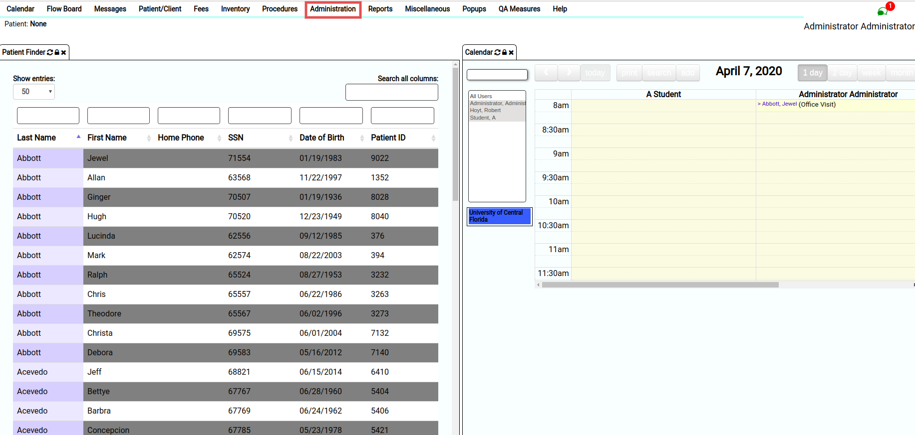

1. Click on Globals (highlighted in red below).

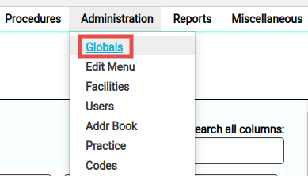

1. Click opens a panel titled “Edit Global Settings” as shown below.
2. Click on “Appearance”

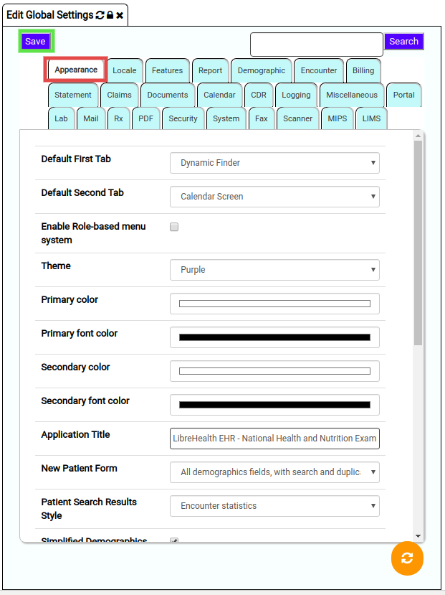

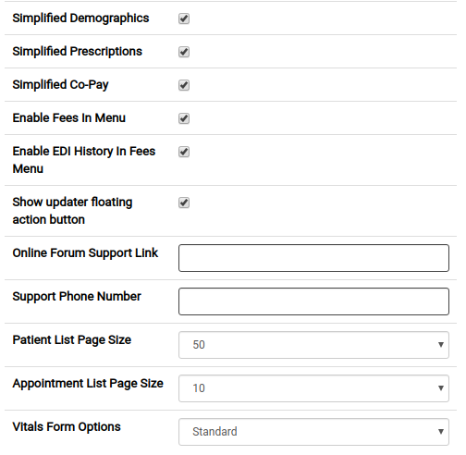

The instructions below provide a guide to edit Appearance of Flow Board using Global Settings.The Appearance tab provides a way to customise the appearance of the home page along with colours, fonts, sizes and other formatting details. The following options are provided for customization:

* Default First Tab: This option allows you to select the module that appears as the default tab on the left hand side on the home page. The default option is set to dynamic finder. To change the default option, click on the downward arrow to open the dropdown and select among the options provided.

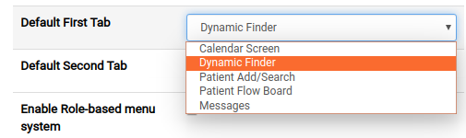

* Default Second Tab: This option allows you to select the module that appears as the second default tab on the home page. The default option is set to Calendar Screen. To change the default option, click on the downward arrow to open the dropdown and select among the options provided.
* Enable Role-based menu system: This option allows you to enable or disable role-based menus. By selecting the checkbox, you enable role-based menus.
* Theme: This option allows you to pick a css theme for the EHR system. The default option is set to purple. To change the theme, click on the downward arrow to open the dropdown and click on your theme of choice.

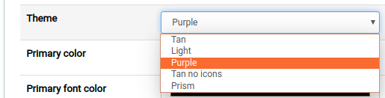

* Primary color: This option allows you to choose the outer background color for the EHR interface. The default color is set to white. To change the primary color click on the field next to “Primary Color”. This opens a color picker; move your mouse around and choose your desired color of choice.



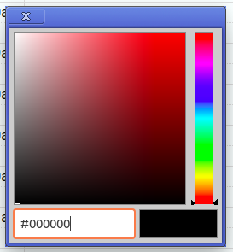

* Primary font color: This option allows you to choose the primary font color for the EHR interface. The default font color is set to black. Similar to above, to change the primary font color click on the field next to “Primary font color”. This opens a color picker; move your mouse around and choose your desired color of choice.



* Secondary color: This option allows you to choose the inner background color for the EHR interface. The default color is set to white. To change the secondary color click on the field next to “Secondary Color”. This opens a color picker; move your mouse around and choose your desired color of choice.
* Secondary font color:This option allows you to choose the secondary font color for the EHR interface. The default font color is set to black. Similar to above, to change the secondary font color click on the field next to “Secondary font color”. This opens a color picker; move your mouse around and choose your desired color of choice.
* **A**pplication title: This option allows you to customize the title of the login page. The default option is set as “LibreHealth EHR - National Health and Nutrition Examination Survey (NHANES)”. To change the default option, click on the text field next to “Application title”.
* New patient form: This option allows you to customize the information included in the new patient form that is used for adding new patients. The default option requests all demographics fields. To change the default option, click on the downward arrow that opens the dropdown menu. From the menu, click on the option of choice.

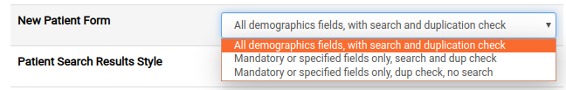

* Patient search results style: This option allows you to select the columns displayed for patient search results. The default option is set to Encounter statistics. To change the default option, click on the downward arrow that opens the dropdown menu. From the menu, click on the option of choice.

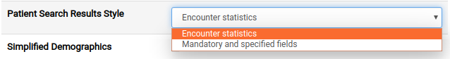

* Simplified demographics: By selecting the checkbox, this option lets you simplify the details in the demographic form such as omitting insurance details from the demographics form. To not simplify the demographics form, unselect the checkbox next to “Simplified Demographics”.
* Simplified prescription: By selecting the checkbox, this option lets you simplify the details in the prescription form such as omitting the root and interval which become part of dosage. To not simplify the prescription form, unselect the checkbox next to “Simplified Prescription”.
* Simplified co-pay: By selecting the checkbox, this option lets you simplify the details in the copay panel such as omitting the method of payment from co-paypanel. To not simplify the co-pay form, unselect the checkbox next to “Simplified co-pay”.
* Enable fees in menu: By selecting the checkbox, this options lets you enable fees in the EHR menu. Un-selecting the checkbox disables the option.
* Enable edi history in fee menu: By selecting the checkbox, this option displays the EDI history (in fees) for storing and interpreting EDI claim response files. Unselecting the checkbox removes the EDI history from the fee menu.
* Show updater floating action button: Selecting the checkbox, enables the updater floating action button at the bottom of the screen. To hide this button, unselect the checkbox.

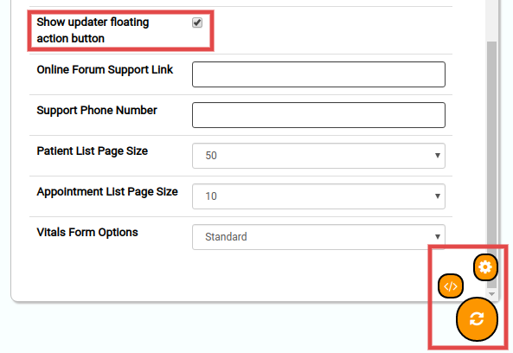

* Online Forum Support Link: This option allows you to list the URL for LibreHealth EHR website. To enter the information, click on the textbox and add the link.
* Support Phone Number: This option allows you to list a support phone number for vendor support that appears on the about page. To enter this information, click on the textbox and add the phone number.
* Patient List Page Size: This option allows you to select the number of patients to display per page in the patient list. The default option is set to 50. To change the default option, click on the downward arrow that opens the dropdown menu. From the menu, click on the option of choice.

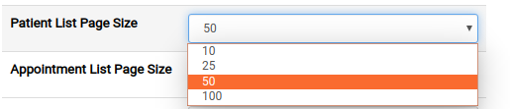

* Appointment List Page Size: This option allows you to select the number of appointments to display per page in the appointments list. The default option is set to 10. To change the default option, click on the downward arrow that opens the dropdown menu. From the menu, click on the option of choice.

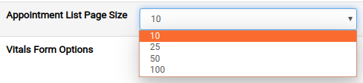

* Vitals Form Options: This option allows you to select the special treatment for vitals form options. The default is set to “Standard”. To change the default option, click on the downward arrow that opens the dropdown menu. From the menu, click on the option of choice.

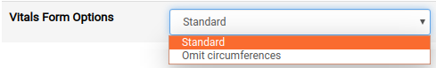

To make changes to Global Settings, follow the instructions above to make modifications and click on “Save” (highlighted in green) before closing the Global Settings panel.



## Summary

This document details the features of the Flow Board and Global Settings modules in the LibreHealth EHR system.